Java Persistence API
Java Persistence API (JPA) is a specification for how to persist objects. It provides a standard set of services for saving objects, associations, and inheritance relationships in a database, in a way that is independent of the database.
When an object is saved to a database, JPA can automatically save associated objects, too, and guarantee object uniqueness. When you create an object from the database, JPA can automatically create associated objects and guarantees that only one object is created for each row in a database table.
JPA is only one choice for object persistence. Other choices are Java Data Objects (JDO), which has a broader scope but less widely used, and object-relational mapping (ORM) frameworks such as Hibernate. Hibernate is the basis for many JPA features (such as criteria queries) and Hibernate itself implements JPA. Knowing JPA is useful because it is so widely used (Google App Engine supports JPA), and the concepts can be applied to learning JDO, Hibernate, or other frameworks.
This lab covers the basics of JPA 2.0 in a stand-alone Java SE application.

Topics
1. A persistence example.
2. Overview of object persistence concept and how JPA works.
3. Create a JPA application using annotations in Java source code.
4. Create a JPA application using XML for configuration and no annotations.
5. Using IDE tools to automatically create Entities or schema.

Required Software
1. Java SE 1.6.0 SDK (version 1.5 will work as well).
2. MySQL or Derby database.
3. EclipseLink 2.x, an implementation of JPA 2.0.
4. Eclipse or NetBeans. It is helpful to have plugins for database development and JPA project support (Eclipse DALI extensions). These are not essential: you use JPA with any Java development tools, you just have to do more typing.

The World Database
World is a sample database provided by MySQL. The data is from the 1990s, but it's still useful. There are 3 tables as shown below. It has a simple design; most fields are Strings (CHAR(n)) or numeric types. The COUNTRYLANGUAGE table uses a compound key.
COUNTRY table
Code <PK>
Capital
Continent
GNP
LifeExpectancy
LocalName
Name
Population
Region
CITY table
ID <PK>
CountryCode
District
Name
Population
COUNTRYLANGUAGE
CountryCode <PK>
Language <PK>
isOfficial
Percentage

Contents

Java Persistence API 1
Contents 2
JPA Example using the World Database 2
2. Country Search 5
3. Create and Save a Country 7
4. Object Persistence Concepts 10
5. How JPA Works 10
6. JPA Basics 11
7. Implementing Data Access Objects using JPA 15
8. Factory for DAO 15
9. Annotations 17
10. Entity Relationships 18
11. Fetching Strategy: Eager and Lazy Fetching 21
12. Cascading Operations 22
13. Persistence Operations for find, save, update, and delete 22
14. JPA Plugins for Eclipse and NetBeans 26
15. Persistence using IDE JPA Tools and Annotations 28
16. Using JPA with Existing Eclipse Projects 33
17. Entity Mapping using XML 34
18. Installing Software for this Lab 38
19. Resources 39

JPA Example using the World Database
In this example we'll see how easy it is to create City and Country objects from data in the database, and how to save a new Country with a new capital city.
Use your existing World project from the JDBC lab for this example.
We won't use any IDE support for JPA (we will create a new JPA project later using IDE support).
To use JPA in any Java project you need three things:
- The javax.persistence JAR file that contains the JPA 2.0 API and a JPA Provider that provides an implementation of JPA. We will use EclipseLink (eclipselink.jar).
- A configuration file named persistence.xml in a META-INF directory on the classpath.
- A database with JDBC driver. You can use any database that has a JDBC driver.
For a project named "World" the structure will look like this:
World/ the project base directory
src/ source directory
META-INF/ meta-information directory
persistence.xml JPA configuration file
world / base package for our source classes
domain/ package for domain classes
City.java domain class for City objects
bin/ Generated class files. The name may
... be "build/classes" or other name.
Referenced Libraries/
eclipselink.jar JPA 2.x provider (EclipseLink)
javax.persistence_2.0.3xxx.jar JPA 2.0 API
mysql-connector-java-5.1.7.jar JDBC connector for MySQL, or
derby.jar JDBC connector for Derby database

Add EclipseLink and javax.persistence to project
Install EclipseLink (current version is 2.3.2) in your software library.
The eclipselink.jar is the the eclipselink/jlib directory. javax.persistence_2.x.y.jar is in the jlib/jpa directory. Don't add javax.persistence_1.0.0.jar to your project.

Create persistence.xml
The file named persistence.xml contains JPA configuration information for your application. This file should be in a META-INF directory inside your project source (src) folder.
The persistence information specific to this project is shown in bold type.
<?xml version="1.0" encoding="UTF-8"?>
<persistence version="2.0"
xmlns="http://java.sun.com/xml/ns/persistence"
xmlns:xsi="http://www.w3.org/2001/XMLSchema-instance"
xsi:schemaLocation="http://java.sun.com/xml/ns/persistence
http://java.sun.com/xml/ns/persistence/persistence_2_0.xsd">

<persistence-unit name="world" transaction-type="RESOURCE_LOCAL">
<provider>org.eclipse.persistence.jpa.PersistenceProvider</provider>
<class>world.domain.City</class>
<properties>
<property name="javax.persistence.jdbc.url"
value="jdbc:mysql://se.cpe.ku.ac.th:3306/world"/>
<property name="javax.persistence.jdbc.driver"
value="com.mysql.jdbc.Driver"/>
<property name="javax.persistence.jdbc.password" value="student"/>
<property name="javax.persistence.jdbc.user" value="secret"/>
</properties>
</persistence-unit>
</persistence>
If you are using the Derby database in embedded mode, use the following:
<property name="javax.persistence.jdbc.url"
value="jdbc:derby:D:/database/world"/>
<property name="javax.persistence.jdbc.driver"
value="org.apache.derby.jdbc.EmbeddedDriver"/>
<property name="javax.persistence.jdbc.password" value=""/>
<property name="javax.persistence.jdbc.user" value=""/>

Use Eclipse to Validate your persistence.xml
In Eclipse, right-click on persistence.xml and choose Validate. Eclipse will validate the file against the schema and report syntax errors. Eclipse may try to get the schema (xsd) file over the Internet. To avoid using the Internet you can add the JPA schema it to Eclipse's Schema Catalog (in the Preferences -> XML dialog). EclipseLink includes the schema files in the xsds directory.

Query a City using JPA
In the world package create a JPADemo.java class (you can use any name, except Main).
Write a method to search for Cities by name using JPA, and print the matches. This code invokes the City.toString() method to print the city info, so make sure your City class has a toString method.
package world;
import java.util.List;
import javax.persistence.*;
import world.domain.*;
"world" is name of the persistence-unit in the persistence.xml file, not the name of the database.

public class JPADemo {
/**
* Find cities in database by name.
* @param name is the name of city to find.
*/
public static void findCity(String name) {
EntityManagerFactory factory =
Persistence.createEntityManagerFactory("world");
EntityManager em = factory.createEntityManager();
Query query =
em.createQuery("SELECT c from City c where c.name = :name");
query.setParameter("name", name);
List<City> cities = query.getResultList();
System.out.printf("Found %d matches for %s\n", cities.size(), name);
for(City c : cities) System.out.println( c );
}

public static void main(String[] args) {
findCity("Los Angeles");
}
}
That's it! JPA will automatically create City objects when we query the database.
We also need to annotate the City class, so JPA knows that this class is a persistent class (called an Entity) and which field is the ID field. Add these annotations to world.domain.City:
package world.domain;
import javax.persistence.Entity;
import javax.persistence.Id;

/**
* A City in a country.
* @author James Brucker
*/
Annotations begin with @ sign.
@Entity
public class City {
@Id
private Integer id;
private String name;
private String district;
private int population;
Run the JPADemo class. If you get an exception from JPA, look at the message at the top of the exception trace to find the root cause. Common problems are:
- the database server isn't running (this is not a problem with Derby or HSQLDB)
- using embedded Derby, but there is another open connection to the world database
- wrong database info, such as username, password, or URL, or missing JDBC driver JAR file
- didn't include <class>world.domain.City</class> in persistence.xml
- typing error for values in the XML file
Fix any errors until the program runs.

JPA Query Language: An Object-based Query Language
In the above example, to query a city we wrote:
Query query =
em.createQuery("SELECT c from City c where c.name = :name");
query.setParameter("name", name);
List<City> cities = query.getResultList();
This looks like SQL but it is written in terms of classes and attributes, not database tables and fields. "City c" defines a City object reference c (just like Java). c.name refers to the name attribute of the City class -- not the NAME field in the database table.
This uncouples JPA from the database schema. The CITY table does not need to have the same name as the class -- the table could be CITIES or something else, without affecting the query.
The query string contains a named parameter (:name), which is identified by the leading colon. query.setParameter("name",value) inserts a value for the parameter.

Country Search
Country
-code: String
-name: String
-continent: String
-region: String
-population: long
1. Create a Country class containing the attributes shown at right.
2. Write (or auto-generate) the following methods:
a protected default constructor
get/set methods for all attributes
a toString method that returns the country name, continent, and population. There should only be one match for a country name, so don't print "Found n matches for ...".
3. Add JPA annotations to Country, like you did for the City class.
4. Add world.domain.Country to persistence.xml as a <class> element.
5. Write a findCountry method in JPADemo, and modify the main method to ask the user what country to find (in a loop) and print results. For example:
Country to find: Poland
Poland in Europe, population 38,653,600
Country to find: Siam
No matches for Siam
Country to find:
Run JPADemo until you can successfully find countries in the database.

Add a Capital City to Country
A country has a capital City. In the COUNTRY table this is a foreign key reference to a CITY row.
In Java, capital should be a reference to a City object (not a number).
2.1.1 Add a capital City reference to the Country class, as shown below.
2.1.2 Add getCapital and setCapital methods for the capital.
City
Country
-code: String
-name: String
-capital: City

+getCapital( ): City
+setCapital( City )
2.1.3 Annotate the capital attribute so that JPA knows that capital is a reference to a City Entity.
@Entity
public class Country {
...
// capital is a reference to a City object
@ManyToOne
@JoinColumn(name="capital")
private City capital;
2.1.4 Modify the findCountry method to print the country's capital city. When you get a Country object, JPA will automatically create the capital city, too. So you simply invoke country.getCapital().
Country to find: Argentina
Argentina in South America, population 37,032,000
The capital city is Buenos Aires, Distrito Federal pop. 2,982,146
Country to find: Thailand
Thailand in Asia, population 61,399,000
The capital city is Bangkok, Bangkok pop. 6,320,174
Country to find:

Add a Bidirectional Association Between Country and Cities
Every city belongs to a country, and a country has a collection of cities.
Country
City
country
1
cities
*

This is a bidirectional association. From the City side, it is many-to-one (City has a country).
From the Country side, it is one-to-many (Country has a collection of cities).
Maintaining consistency of bidirectional relationships in Java is not easy! You have to make sure that whenever one side of the association is set or changed that the other side is updated, too. JPA handles this by designating one side of the relationship as the controlling side.
2.2.1 Add a country attribute and getCountry/setCountry methods to City class.
If your City class has a countrycode attribute, then DELETE THE ATTRIBUTE.
2.2.2 Annotate the country attribute of City so JPA knows how to set it:
@Entity
public class City {
@Id
private Integer id;
private String name;
private String district;
private int population;
@ManyToOne
@JoinColumn(name="countrycode")
private Country country;
2.2.3 Modify the findCity() method so it also prints the Country where the city resides. Use city.getCountry().getName().
City to find: Bangkok
Bangkok, Bangkok pop. 6,320,174 located in Thailand
2.2.4 Add a cities collection (a Set) to the Country class. Also add getCities and setCities methods to access the Set. Include a JPA @OneToMany annotation for this set:
@Entity
public class Country {
@Id
private String code;
...
@OneToMany(mappedBy="country", fetch=FetchType.LAZY)
private Set<City> cities;
The @OneToMany annotation identifies a one-to-many association; mappedBy="country" tells JPA that members of the Set are determined by the country attribute on the other side of the association (City). JPA can infer which Entity class is on the other end by the type parameter of the Set. For bidirectional associations, one end "controls" the association and determines what values are persisted.
fetch=FetchType.LAZY specifies that objects for the Set of Cities should not be created until the application tries to access the cities (lazy instantiation). This avoids wasting time creating objects that your application never uses.
2.2.5 Modify findCountry in JPADemo to print all the cities in a country:
Country to find: Thailand
Thailand in Asia, population 61,399,000
The capital city is Bangkok, Bangkok pop. 6,320,174
Cities in Thailand
Udon Thani, Udon Thani pop. 158,100
Chiang Mai, Chiang Mai pop. 171,100
Nakhon Ratchasima, Nakhon Ratchasima pop. 181,400
Pak Kret, Nonthaburi pop. 126,055
...
Country to find: Japan
Japan in Asia, population 126,714,000
The capital city is Tokyo, Tokyo-to pop. 7,980,230
Cities in Japan
Kakogawa, Hyogo pop. 266,281
Ibaraki, Osaka pop. 261,020
Ichinomiya, Aichi pop. 270,828
Tokushima, Tokushima pop. 269,649
Yamagata, Yamagata pop. 255,617
...

Create and Save a Country
We will create a new Country named JavaLand with capital city Espresso. We'll save the country object to the database using JPA and then try to find it using the findCity or findCountry methods.
Since we only want to save the objects once, create a new class named PersistDemo.
3.1 Create the Country and City objects. Set values for the capital (in Country) and country (in City).
package world;
import javax.persistence.*;
import world.domain.*;

public class PersistDemo {

public static void main(String[] args) {
// Set the attributes using a constructor or setXxx methods
Country java = new Country("JavaLand", "South America", 1000000);
java.setRegion("Eastern");
java.setCode("JAV");

City espresso = new City("Espresso");
espresso.setDistrict("Beans");
espresso.setPopulation(20000);
espresso.setCountry(java);
java.setCapital(espresso);
// code continued below
Use an EntityManager to save objects. Objects are saved and updated as part of an EntityTransaction. A transaction lets you perform several operations at once, and cancel all the operations if any error occurs.
Add the following code to the main method of PersistDemo:
EntityManagerFactory factory =
Persistence.createEntityManagerFactory("world");
EntityManager em = factory.createEntityManager();
EntityTransaction tx = em.getTransaction();
tx.begin();
em.persist(java); // save the country. what about city?
tx.commit();

// was an ID assigned to the city?
System.out.println("After saving city id is "+espresso.getId());
// close the connection
em.close();
factory.close();
}
}
3.2 When you save one object, you usually want to save associated objects, too. This is called cascading. To specify that related objects should be cascaded, add the following to the Country class:
@Entity
public class Country {
@Id
private String code;
private String name;
private String continent;
private long population;
@ManyToOne(cascade=CascadeType.PERSIST) //or: CascadeType.ALL
@JoinColumn(name="capital")
private City capital;
...
This means: when you persist a new country also persist its capital city if that city hasn't been persisted already.
3.3 Also add cascade=CascadeType.PERSIST to the City class.
3.4 For the CITY table the database assigns an ID to each City. We need to inform JPA that the City id will be assigned by the database using a @GeneratedValue annotation:
@Entity
public class City {
@Id
@GeneratedValue(strategy=GenerationType.IDENTITY)
private Integer id;
private String name;
private String district;
private int population;
@ManyToOne(cascade=CascadeType.PERSIST)
@JoinColumn(name="countrycode")
private Country country;
There are other values for both GeneratorType and cascade. A common choice for cascading is cascade=CascadeType.ALL, which means all database operations on one object should cascade to related objects (including deleting objects).
3.5 Run PersistDemo. Fix any errors until it saves the country and city. Use JPADemo to verify that a new country and city where added to the database.

Object Persistence Concepts
Object persistence means saving information about objects to non-volatile storage so it "persists" after the application exits. Persistence includes saving and updating objects and their associations to other objects, searching for saved objects, recreating objects from storage, and managing object identity.
Persistence is needed by many applications, so it makes sense to implement persistence services as a reusable framework. There are several persistence frameworks such as Hibernate and TopLink; they each have their own API. To make persistence more portable and avoid vendor lock-in, the Java community defined a standard for persistence services, namely the Java Persistence Architecture (JPA).
JPA version 2 can be used in two contexts: in an enterprise application (JavaEE) that runs in a container, or in a stand-alone application using Java SE.

How JPA Works
The Java Persistence Architecture provides an abstraction that hides the details of object persistence. An EntityManager provides services that your application uses to query, save, update, or delete persistent objects, called entities.
EntityManager is just an interface. A concrete EntityManager is provided by an implementation of JPA, called a Persistence Provider. Applications use an Entity Manager Factory to create a concrete instance of EntityManager based on configuration data. For enterprise applications, the Java EE container injects the EntityManager into your app (using annotations); your app does not create it itself.
In this lab, we'll use EclipseLink as the JPA persistence provider. Other JPA providers are Hibernate, OpenJPA, TopLink Essentials, and DataNucleus (see Resources at end).
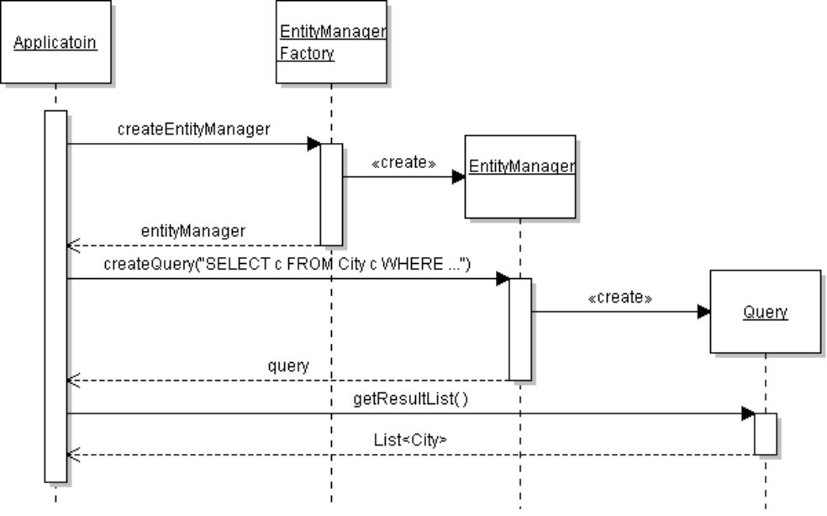
Persistent Storage
The Java code for the above sequence is:
final String PERSISTENCE_UNIT = "world"; // name as in persistence.xml
factory = Persistence.createEntityManagerFactory(PERSISTENCE_UNIT);
EntityManager em = factory.createEntityManager();
Query query = em.createQuery(
"SELECT c FROM City c WHERE c.name=:name" );
query.setParameter("name", "Bangkok");
List<City> results = query.getResultList();
for( City city: results ) System.out.println( city );
The createQuery method uses a String in Java Persistence Query Language (JPQL):
SELECT c FROM City c WHERE c.name = 'Bangkok'
This looks like SQL but is written in terms of classes and attributes, not tables. "City c" means a City object c, like in Java. A query returns objects (entities), as shown in the query.getResultList( ).

JPA Basics
In JPA, an Entity is a class whose objects are persisted. Each entity class is mapped to a table in a database. Some frameworks can persist objects to other forms of storage, such as XML files, LDAP directory, or even an Excel spreadsheet! (DataNucleus can do this.)
You have to describe your Entities to JPA, such as what attribute is the primary key, what attributes to save, the database table, and associations with other entities.
There are two ways to describe entities and their properties:
- annotations in Java source code
- XML mapping file containing the same information, but in XML
Both ways have advantages and disadvantages. You will use both in this lab.

Structure of a Java JPA Project
For a project named "WorldJPA" the structure will look like this:
WorldJPA/ the project base directory
src/ source directory
META-INF/ meta-information directory
persistence.xml JPA configuration file
orm.xml O-R mapping file (optional)
world / base package for our source classes
domain/ package for domain classes
Country.java domain class for Country objects
bin/ Generated class files. The name may
... be "build/classes" or other.
Referenced Libraries/
eclipselink.jar JPA 2.x provider (EclipseLink)
javax.persistence_2.xxx.jar JPA API
mysql-connector-java-5.1.7.jar JDBC connector for your database

The Persistence Configuration File persistence.xml
The file named persistence.xml contains JPA configuration information for your application. This file should be in a META-INF directory inside your project source (src) folder.
persistence.xml specifies persistence information specific to your project, shown in bold type:
<?xml version="1.0" encoding="UTF-8"?>
<persistence version="2.0"
xmlns="http://java.sun.com/xml/ns/persistence"
xmlns:xsi="http://www.w3.org/2001/XMLSchema-instance"
xsi:schemaLocation="http://java.sun.com/xml/ns/persistence
http://java.sun.com/xml/ns/persistence/persistence_2_0.xsd">

<persistence-unit name="world" transaction-type="RESOURCE_LOCAL">
<provider>org.eclipse.persistence.jpa.PersistenceProvider</provider>
<class>world.domain.City</class>
<properties>
<property name="javax.persistence.jdbc.url"
value="jdbc:mysql://se.cpe.ku.ac.th:3306/world"/>
<property name="javax.persistence.jdbc.driver"
value="com.mysql.jdbc.Driver"/>
<property name="javax.persistence.jdbc.password" value="student"/>
<property name="javax.persistence.jdbc.user" value="secret"/>
</properties>
</persistence-unit>
</persistence>
Note: In the xml header you can delete the long xsi:schemaLocation if you add persistence_2_0.xsd to your IDE's Schema catalog, so the IDE can validate the XML. This avoids connecting to the Internet to get the schema.
persistence version="2.0" (or newer). Make sure this is not 1.0.
<persistence-unit name="world"> a persistence unit is a group of related entities. You can use any name; usually it is the database name.
transaction-type="RESOURCE_LOCAL" for a stand-alone application, "JTA" for managed app.
provider is the Java path of the JPA Persistence Provider. We are using EclipseLink.
class (zero or more times) are names of Entity classes in our application.
properties JPA 2.0 specifies standard property names for URL, JDBC driver, user, and password. The JPA property keys all begin with javax.persistence as shown above. JPA providers can add optional properties which don't begin with "javax.persistence".
persistence.xml may contain more than one persistence-unit, each in its own section.
A persistence-unit may also contain:
<mapping-file> (zero or more times) the name of a file containing object mapping info as XML. This file is usually named orm.xml in the META-INF directory, but you can use any name and location. Some developers prefer to put mapping files in the same source directory as classes being mapped. In our application we will use:
<mapping-file>META-INF/orm.xml</mapping-file>

Stand-alone and Container-Managed Modes
In our application we created an EntityManagerFactory and EntityManager in code. This is called Application Managed or stand-alone mode. Creating an EntityManagerFactory and EntityManager takes time, and some apps require that the same Entity Manager be used throughout.
JPA defines managed modes for both the factory and entity manager. If the application is using a dependency injection container (like Spring Framework) you can inject a reference to the EntityManagerFactory. This saves time and enables sharing of the factory. Your application still creates its own EntityManager.
// create a factory by resource injection
@PersistenceUnit
EntityManagerFactory factory;
The other way to use JPA is Container-Managed mode. A Java Application server (Java EE) can create and inject the EntityManager for you, so different parts of your app can easily access the same instance. In container-managed mode you obtain an EntityManager using:
@PersistenceContext
EntityManager em;
For this mode also need to set transaction-type="JTA" in persistence.xml. The Java EE Tutorial describes how to use Container-Managed mode for Entity Managers.

Entity Classes
An entity class is a class whose objects are persisted. To be an Entity in JPA, a class must satisfy:
- Class has a non-private no-argument constructor (default constructor). protected is OK.
- get/set methods for persistent attributes, using Java standard naming convention. JPA providers can set private attributes directly, so you may be able to make set methods private (try it).
- Class must not be final. Persisted variables and their get/set methods are not final, either.
- Class must define an ID attribute that uniquely identifies each instance. This is usually the primary key of the table in a database. The ID can be a compound attribute.
Both abstract and concrete classes can be entities. An entity class can extend another class.
If an entity class will be used in a collection, then you should also specify:
- Meaningful equals() and hashCode() methods to find an object in the collection. The id attribute is usually a good choice for comparison in equals and the hashCode.

A City Entity using Annotations
To make the City class an entity, add the annotations below.
package world.domain;
import javax.persistence.*; // for annotation classes

@Entity
public class City {
@Id
@GeneratedValue(strategy=GeneratorType.IDENTITY)
private Integer id;
private String name;
private String district;
private int population;
@ManyToOne
@JoinColumn(name="CountryCode")
private Country country;

/** required default constructor may be public or protected */
protected City( ) { }
//TODO get/set methods for all attributes
//TODO equals method. Use the id attribute for comparison.
//TODO a toString() method
}
JPA maps attributes to table columns having the same name, using a case insensitive match. JPA is very lenient about conversion of SQL data types to/from Java data types. An SQL INTEGER type can be mapped to a Java int, long, Integer, or Long (with possible loss of data). Similarly, a Java String can be persisted to SQL CHAR(n) or VARCHAR(n), with possible truncation of the string.
We'll cover more annotations below, but first, how to persist entities?

Implementing Data Access Objects using JPA
In the previous examples, we write JPA code to query and save objects in a test (main) class, so we could see how to use JPA. In your application though, you should define a separate component for handling persistence and put all JPA in that component and nowhere else.
Software design principles recommend that we design for separation of concerns, low coupling, and protected variations via a layer of abstraction. Here we'll see how to achieve this using Data Access Objects (DAO) for persistence and a factory class to create the DAO
A data access objects (DAO) provide persistence services (the CRUD operations). This encapsulates the services so they are easy to change. You can have just one DAO for a small application, or one DAO for each entity type. We would also like to (1) separate database and schema information from our Java code, (2) provide an interface for DAOs so we can provide alternative DAOs for different persistence frameworks.
A typical DAO has methods such as:
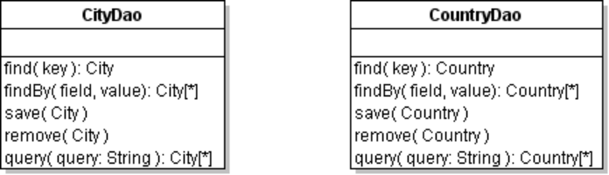
To provide protected variations and make it easy to test code, you should define an interface for each DAO and have your actual DAO implement the interface -- usually in a separate package.
Here's an example:
package world.persistence
<<interface>>
CityDao
find( int ): City
findAll( ): List<City>
save( City )
remove( City )
query( String ): List<City>

package world.persistence.jpa
CityDaoJpa
-em: EntityManager
CityDaoJpa(EntityManager)
find( int ): City
findAll( ): List<City>
save( City )
remove( City )
query( String ): List<City>

Notice that we inject the EntityManager into CityDaoJpa.

Exercise: Write a CityDao
1. Implement the methods in the UML diagram above.

Factory for DAO
We need a way to access DAO objects without knowing details of how to create them. Plus, we really only need one instance of each Dao. Use the Factory Method pattern for this.
The factory should have a getXxxxDao() method for each kind of DAO in your application. Define an abstract class for the base DAO, and a concrete implementation for JPA using the same packages as your DAO classes:
package world.persistence
DaoFactory {abstract}
getInstance( ): DaoFactory
getCityDao( ): CityDao
getCountryDao(): CountryDao
In the abstract factory, you implement
only the static getInstance() method.
Other methods are abstract.

package world.persistence.jpa
JpaDaoFactory
-em: EntityManager

getCityDao(): CityDao
getCountryDao(): CountryDao
Implement methods to create a single
instance of each JPA DAO object.

class JpaDaoFactory extends DaoFactory {
private static final String PERSISTENCE_UNIT = "world";
private CityDao cityDao;
private CountryDao countryDao;
private EntityManager em;
private EntityManagerFactory emf;
public JpaDaoFactory( ) {
emf = Persistence.createEntityManagerFactory(PERSISTENCE_UNIT);
em = emf.createEntityManager();
}
/** lazy singleton accessor for the CityDao */
public CityDao getCityDao() {
if (cityDao == null) cityDao = new CityDaoJpa(em);
return cityDao;
}

We haven't yet seen how to implement the DaoFactory.getInstance() method, which decides at runtime which DaoFactory to instantiate (e.g. JpaDaoFactoryJpa or MockDaoFactory, ...). Larman, chapter 27 has example of this. Using this pattern, in your application you can persist a City by simply writing:
CityDao dao = DaoFactory.getInstance().getCityDao();
dao.save( city );
Your application does not need to worry about how the Dao are created or how the persistence is done.

Exercise: Write DaoFactory and JpaDaoFactory
1. In DaoFactory, all methods are abstract except getInstance(). getInstance() returns a singleton instance of a concrete DAO Factory. You can just "hardcode" it to return a JpaDaoFactory.

Annotations

Where to Put Annotations?
Attribute annotations tell JPA how to persist the class's attributes. The annotations can be written in either of two places:
1) field: annotations appear before attribute (field) names
@Id
private Integer id;
2) accessor: annotations appear before get methods.
@Id
public Integer getId( )
field annotations have the advantage that the annotations are closer together. If you use "accessor" annotations, then in your classes you should always use getXxx methods to access fields rather than directly accessing them. That is, you should use obj.getXxx() instead of obj.xxx.
You can use either location for annotations (field or accessor)
but you may not combine them in one class.

Annotations for Class and Table
An entity class has the annotation @Entity before the class declaration.
@Entity
public class City {
By default, JPA assumes the name of the database table is the same as the entity class name. City (class) objects are persisted to a City table. JPA does a case-insensitive match of table name, so table CITY or city will also work. To specify a table name for the mapping, use @Table annotation:
@Entity
@Table(name="CITIES")
public class City {

Mapping of Attributes using Annotations
JPA assumes object attribute names map to table columns with the same name, for supported data types. It maps camelCase field names to underscore in column names (camel_case).
JPA automatically maps Java basic types (primitives, wrapper types, and String) to a corresponding SQL type. JPA uses intuitive, flexible rules. For example, both int and Integer map to INTEGER.
If the table column name is not the same as object attribute name, specify the name in an annotation. For example, the County attribute yearOfIndependence is saved in table column IndepYear:
@Column(name="IndepYear")
private int yearOfIndependence;
There is ambiguity in mapping of some data types, esp. date, time, and strings. The code field is CHAR(3) in the Country table, but String in Java. You can specify mapping details in annotations:
@Column(name="code", length=3, nullable=false)
private String code;

Summary of Common JPA Annotations
Persistence metadata is the information JPA needs to persist objects. It can be specified as annotations in Java source code or in XML files.
Here is a summary of common annotations. Examples of each of them are given below.
@Entity  public class City | Identifies a persistent class. By default, the table name is the same as the class name. The second form lets you specify the table name.
@Table(name="CITIES")  public class City { } | Optional annotation for table name, if not same as class name.
@Id  private String code; | Indicate attribute that is the primary key in database table.
@Id  @GeneratedValue  private String ID; | Indicates an attribute value is generated automatically by database.
@Transient  public double gnpPerCapita;; | An attribute that should not be persisted in database.
@Column(name="name")  @Column(name="name",  length=30,  unique=true)  String name; | Specify name of column and width (for Strings). For numeric types, use precision instead.
@OneToOne | Annotation for attributes that are associations to other persisted objects.
// in city class  @ManyToOne  private Country country; | Association to another object using a foreign key reference. Default field is country_code and target table determined by the class of attribute (Country).
@ManyToOne  @JoinColumn(name="capital"  referencedColumnName="ID")  City capital; | Default column name is the attribute name + "_" + name of key in target table. So the default for captal would be capital_ID.
@OneToMany(mappedBy="country", cascade=CascadeType.PERSIST)  private Collection<City> cities; | A Country has a collection of cities. It is an inverse map that is mapped by the country field in the City class.

Entity Relationships
Objects usually contain references to other objects. JPA can preserve these relationships. For example, a City refers to the Country it is part of. A Country has a reference to its capital City.
There are 4 types of associations:
- One-to-one
- One-to-many
- Many-to-one (ordered or unordered)
- Many-to-many (ordered or unordered)
In addition, relationships can be one-sided (unidirectional) or two-sided (bidirectional).
One-sided: a Country has a reference to its capital City. | 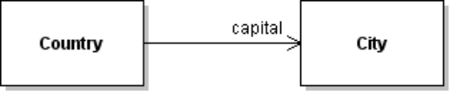
Two-sided: a City refers to its Country, and the Country maintains a collection of its Cities. | 

One-to-One
A Country object has a reference to its capital City. This is determined by the capital field in the country table. No other Country object will refer to the same City, so it is a one-to-one association. To implement this association in Java we need:
@OneToOne
@JoinColumn(name="Capital", referencedColumnName="ID")
private City capital;
The referencedColumnName specifies a column in the other table to JOIN with the JoinColumn in this table. The default is to use the primary key (so in this example we don't really need to write referencedColumnName=...).
The association between Country capital and City can also be modeled as a many-to-one association, even though no two countries have the same capital city.

Many-to-One
Many cities refer to the same country. This is a many-to-one association from City to Country. In the City class write:
@ManyToOne(optional=false)
@JoinColumn(name="CountryCode", fetch=FetchType.LAZY)
private Country country;
@JoinColumn identifies the join column name in the City table. It will be joined to the primary key (code) in the Country table, since we didn't specify a referencedColumnName.

One-to-Many
A one-to-many association is a collection. It can be ordered or unordered. If order is important, an additional field is needed in the database table to record the ordinal values. Unordered associations are usually modeled as a Set.
A one-to-many association can be unidirectional (that is, a Country knows its cities but each City doesn't refer to a Country) or bidirectional (each City also knows its Country). In either case, in the database the table on the "many" end (City) must have a column to relate to Country. This is City.CountryCode in our database.
You must declare persistent collections using an interface type: Set, List, or Collection. You can use List even if the database doesn't preserve List element ordering.
In the Country class, add a cities collection (Collection, List, or Set) and get/set methods.
private Collection<City> cities; // can be Collection, List, or Set
private Collection<City> getCities() { return cities; }
private void setCities(Collection<City> c) { this.cities = c; }

To specify a collection as a unidirectional One-to-Many association, annotate the Collection or List or Set with @OneToMany and @JoinColumn:
class Country {
@OneToMany
@JoinColumn(name="CountryCode") // refers to City.CountryCode
private Collection<City> cities;
In the World application, a Country has a collection of its cities and each City knows it's Country, so this is a bidirectional association. For a bidirectional association, don't use @JoinColumn. Instead use mappedBy="country" to specify that this association the inverse end and it is controlled by the country attribute in the City class (many-to-one association):
class Country {
@OneToMany(mappedBy="country")
private Collection<City> cities; // inverse of City.country map
In the City class, you annotate the country attribute as shown in previous section.

Bidirectional Association
A bidirectional association is one where there is a reference on both ends. In the previous section we saw that a one-to-many association can be one end of a bidirectional association. One-to-one and many-to-many associations can also be bidirectional.
Bidirectional relationships present a problem: how to keep the two ends of the association consistent? Here is a simple example in Java, using the code for City and Country:
City sangkhla = citySearch.findCity("Sangklaburi"); // in Kanchanaburi
// moved to Burma!!!
Country burma = countrySearch.findCountry("Myanmar");
sangkhla.setCountry( burma );
// the cities collection for Thailand and Burma must be updated, too!
Persistence frameworks, including JPA, address this problem by designating one end of the association as primary or controlling and the other end is designated as secondary or mapped. The framework guarantees to maintain consistency if you make a change on the primary end. But if you make a change on the inverse end the association is not guaranteed to remain consistent.
Typically, the many-to-one end is primary (e.g. City -> Country). This is since the reference column is contained in the table on the "many" end.
Consistency: It is mostly up to the programmer to ensure that both ends of a bidirectional association are consistent. JPA in general won't do it.
Acyclic Dependencies: A bidirectional association violates the acyclic dependency principle in software design. For the World database this violation is reasonable: the cycle involves only two classes and they need to refer to each other in the application anyway. The associations don't change, to maintaining consistency isn't a problem.

Any Association can be Bidirectional
One-to-one and many-to-many associations can also be bidirectional.

Fetching Strategy: Eager and Lazy Fetching
The world database contains 343 cities in China. When we create a Country object for China using JPA, it must create the cities collection and the capital city reference. Should JPA create City objects for capital and all members of the cities collection?
City

Country
code = "CHN"
name = "China"
cities is Set of 343 cities

country
city

For example:
Country china = em.find( Country.class, "CHN");
// how many objects are created from database???
Should JPA instantiate all 343 City objects in the china.cities collection?
Our application might never reference those objects, resulting in a lot of wasted I/O and memory.
It would be more efficient if JPA could wait until the first time our application accessed the City objects.
JPA provides two fetching strategies for when associated objects are instantiated:
fetch="EAGER" when instantiating an entity, load all referenced entities immediately.
fetch="LAZY" when instantiating an entity, don't create referenced entities until they are accessed. The referenced objects will be created the first time they are accessed by the application (which may be never).
You can see the difference in our JPADemo program. In the showCountry() method, add code to display the class name of the cities collection:
Collection<City> cities = country.getCities();
System.out.println("cities is of type " + cities.getClass().getName() );
In orm.xml, the one-to-many mapping for cities has fetch="EAGER". Run JPADemo and search for a country. It should print:
cities has type java.util.HashSet
No surprise -- an ordinary Set. Now change orm.xml to use LAZY fetching of cities:
<one-to-many name="cities" mapped-by="country" fetch="LAZY">
</one-to-many>
When you run JPADemo again and search for a country it will print:
cities has type org.eclipse.persistence.indirection.IndirectSet
IndirectSet is a set that lazily Instantiates City objects as needed.
Lazy fetching is usually more efficient than eager fetching, but has a potential problem. If you detach the entity before the associated objects are loaded, it will throw an exception when you try to access the unfetched objects.

Cascading Operations
When we save (persist) a Country, should the capital City be saved, too? If we tell JPA to delete a Country, should it also delete the referenced Cities and capital City?
This behavior is called cascading. You can specify how JPA should cascade each entity association. For example, if we want all persistence operations for a Country to be applied to its capital City, we'd write:
<many-to-one name="capital" fetch="EAGER">
<join-column name="Capital" referenced-column-name="ID"/>
<cascade>
<cascade-all/>
<cascade>
</many-to-one>
Cascading is more complicated than fetching. The books in the references describe cascading in detail.

Persistence Operations for find, save, update, and delete
The standard persistence services are create (save), retrieve, update, and delete. EntityManager provides methods for all of these. It also provides an extensive query syntax, which we have seen above.

Entity States
An entity can have several states:
new - an object not yet persisted
managed - object has been persisted and is currently attached or managed
detached - object has been persisted, but is not currently being managed. Detached objects can be reattached (put back in managed state).
TODO: Explain the entity life cycle.

Save (Persist) an Object
To persist object as a new entity use the persist method. Database updates must be part of a Transaction. In the CtiyDao you would write:
/** save a City to database. */
public void save(City city) {
EntityTransaction tx = em.getTransaction();
tx.begin( );
em.persist(city);
tx.commit();
}
There are 2 things missing from this code: (1) check if city is already in the database. If it is, use em.merge(city) instead of em.persist(city). (2) use a try - catch block around the last 3 statements. If an exception is thrown then call tx.rollback( ) and log the exception or rethrow it.
To save the city of Bangsaen, Chonburi (Thailand) to the database, assuming it hasn't been added yet, use:
CountryDao countryDao = DaoFactory.getInstance().getCountryDao();
Country thailand = countryDao.findByName("THA"); // key for thailand
City bangsaen = new City( "Bangsaen", "Chonburi", 30000 );
city.setCountry( thailand );
CityDao dao = DaoFactory.getInstance().getCityDao( );
dao.save( bangsaen );

Find Entity by Identifier (key)
EntityManager can return an object for a given value of the primary key. This isn't used very often, since key lookup isn't usually part of a domain model. To find the country with code "CHE" use:
Country c = em.find( Country.class, "CHE" );
// the answer is probably not what you expect
There is something amazing here. We saved the return value from em.find() as a Country reference without using a cast. This only seems to work on Entity classes using annotations.

Update an Entity
There are two ways to update an object (entity) in the database.
1. For an entity currently being managed by JPA, just set the attributes.
The database values are updated automatically when you commit the current transaction.
Let's change the population of Thailand. As of 2011, it is 67 million.
EntityTransaction tx = em.getTransaction( );
tx.begin( );
Country thailand = em.find( Country.class, "THA" );
// set the attribute
thailand.setPopulation( 67000000 );
tx.commit();
2. Add an update( ) method to your CityDao and test it.
Query a city, change its population, and save it. Then query the city again. Did the populatiion change?

Delete an Entity
Use em.remove. This removes the city from the database but does not change contents of the object. This is not the same as the detach method, that simple changes the entity state from managed to detached.
// DELETE Bangsaen. Bangsaen sucks. I know - I live there.
Query q = em.createQuery("SELECT c FROM City c WHERE c.name=:name");
q.setParameter("name", "Bangsaen");
City bangsaen = q.getSingleResult(); // exception if more than one match
tx = em.getTransaction( );
tx.begin();
em.remove(bangsaen);
tx.commit();

Exercise
Write the remove( ) method in CityDao and CountryDao.
Test it. Can you delete Bangsaen? I hope so.

JPA Query Language
JPA queries are in terms of classes and objects, not database tables. The syntax is Java Persistence Query Language (JPQL), which borrows from Hibernate Query Language.
To query a city named Bangkok, use:
Query q = em.createQuery(
"SELECT c FROM City c WHERE c.name = 'Bangkok'");
// throws exception if no match or more than 1 match
City city = q.getSingleResult( );
Names of classes and attributes are case-sensitive in JPQL (just like Java).
Correct: select c from City c
Wrong: select c from city c // name of class is "City"
Correct: SELECT c FROM City c // query language words are case-insensitive
Correct: select c from City c where c.name='Bangkok'
Wrong: select c from City c where name='Bangkok' // no object

Queries with Parameters
You can use named parameters or positional parameters in queries, similar to the ? in an SQL PreparedStatement. A named parameter begins with a colon (:) followed by a name (any valid variable name):
Query q = em.createQuery(
"SELECT c FROM City c WHERE c.name = :name");
q.setParameter("name", "Bangkok");
List<City> cities = q.getResultList( );

Using a Collection as Parameter
JPQL has an "x IN set" condition that is used in WHERE expressions. You can use a Java Collection for the values used by "IN". To find all cities in Thailand or Malaysia, use:
Set<String> names = new HashSet<String>();
names.add("Thailand");
names.add("Malaysia");
Query q = em.createQuery(
"SELECT c FROM City c WHERE c.country.name IN :set");
q.setParameter("set", names);
List<City> cities = q.getResultList( );

Type-safe Queries
In the previous examples, we assigned q.getResultList( ) to List of City objects using unchecked type conversion. It's up to the programmer to make sure this will work; otherwise the code will throw a ClassCastException at runtime.
JPA 2.0 has a typed query which is more type-safe that the Query interface in JPA 1.0. TypedQuery has a type parameter for the class of object(s) the query returns.
TypedQuery<City> q = em.createQuery(
"SELECT c FROM City c WHERE c.name = :name", City.class);
q.setParameter("name", "New York");
List<City> cities = q.getResultList( );
Notice the 2nd parameter in createQuery. This creates a query that can only return City objects.

Walking the Object Graph in JPQL
In JPQL you can access attributes of objects using "." notation. This feature is similar to C# properties and EL expressions. For example, to use the name of the country associated with City c, use:
SELECT c FROM City c WHERE c.country.name = 'China'
To find all the cities in China:
Query q = em.createQuery(
"select c from City c where c.country.name = 'China'" );
List<City> cities = q.getResultList( );

Criterion Queries
What if you want to make a query like:
Find cities with population between 100,000 and 500,000
and in a country in Asia
and not in "China" or "Japan"
This would be difficult in JPQL. JPA has Criterion queries for this purpose. The query is built up as a sequence of criteria that must be true or false. Criterion queries are useful for creating a query programmatically from input choices, such an "Advanced Search" on many e-commerce sites.

Query Method in Dao
The query methods you implement in your DAO are determined by what your application needs.
If you need to be able to find cities by name, you might create a findByName method using the example above.
A general findBy( ) method might look like this:
public List<City> findBy(String fieldname, Object value) {
Query q = em.createQuery(
"SELECT c FROM City c where c."+fieldname+" = :x");
q.setParameter("x", value);
return q.getResultList();

Constraints using Annotations
You can specify constraints on attributes of entities, to prevent invalid data from being saved.
1. A City name may be at most 80 character long and may not be null. The @Column annotation is used by JPA to generate a table from a class. If you don't plan to auto-generate the database tables then its not necessary.
public class City {
@NotNull(message="City name must be specified.")
@Size(message="Name length is at most 80.", max=80)
@Column(length=80)
private String name;
2. A constraint can use a regular expression. In the U.S. a ZIPcode must be 5 digits (20410) or 5+4 (20410-1234).
public class Address {
@Pattern(message="Zip code must be 5 digits or 5+4 format.",
regexp="^\\d{5}(\\-\\d{4})?$")
@Column(length=10)
private String zipCode;

JPA Plugins for Eclipse and NetBeans
The IDE plugins for JPA speed up development of JPA projects. They aren't required (as you saw above) but are helpful.
You can use JPA in any Java Project
You don't need to create a JPA project in the IDE, and you are not required to have the IDE's JPA plug-in. You can create the META-INF directory and the required xml files yourself (easier: copy them from another project).
The plug-in makes it easier to use JPA, but it is not required.
To use JPA you do need a JPA Provider such as EclipseLink. (See references for other JPA providers.)

Eclipse Dali Java Persistence Tool and Database Development Tool
Eclipse has two extensions for Java Persistence: (1) the Dali Java Persistence Tools and (2) Database Development tools. If you installed the Eclipse Java EE bundle, Dali and Database Tools are already included. Otherwise, you can add them using these steps:
1. Select Help -> Install New Software.
2. In the "Work with:" combo-box, choose the Eclipse site for your version (Helios, Indigo, etc.) and wait while the list of extensions is loaded.
3. Expand the "Web, XML, and Java EE" node. Click on "Dali Java Persistence Tools" and the optional "Dali - EclipseLink Support". You don't need to install the other extensions in the bundle.
4. You may also want to install the "Database Development" tools so you can access a database from inside of the Eclipse IDE. This is useful for generating Java classes from a database schema.
5. Check the box for "Contact all update sites during install to find required software".
6. Click Next. And wait, and wait. Accept the inscrutable license agreements (you have no choice).

NetBeans JPA and Database Plugins
NetBeans also has plugins for JPA and database development.
1. From the Tools menu select Plugins.
2. In the "Installed' tab, check to see if "Database" and "Java Persistence" plugins are installed.
3. If the plugins are not installed, use the "Available Plugins" tab to select and install them.
Pretty easy -- compared to Eclipse.

Exercise: Create a Database Connection (Optional but Helpful)
Eclipse and Netbeans let you store information about database connections. You can use this to explore the database while working in the IDE, and apply database connection parameters (url, user, password) to a new JPA project. The IDE can also generate Java code from database schema.
NetBeans 7.0:
1. On the left side of workbench, click the Services tab.
2. Right click on Database and choose "New Connection"
3. Select a database driver. "Java DB (Embedded)" is Derby. Change the driver JAR file if needed.
4. Click Next. Enter database URL, user name, and password. If your database doesn't require a user or password (e.g. Derby), use empty strings for user and password.
5. Test the connection and fix any problems.
Eclipse Helios
To create a database connection:
1. In Window -> View, open the "Database Source Explorer" view. Right click on "Database Connections" and choose New.
2. Choose connector type (MySQL, Derby, etc). Eclipse provides only the "profile" for connectors. You must supply a JDBC connector JAR for the database, or create a Library for it. Click Next.
3. Enter database name or url, user, and password. Test the connection.
4. Click Next to view summary. Note the database URL.
5. Click Finish.
For Derby, remember to close the connection in database explorer. Otherwise your application will not be able to connect.

Persistence using IDE JPA Tools and Annotations

Create a JPA Project in Eclipse
1. If you have the Dali JPA extension installed, select File -> New -> Other... -> JPA Project. Name the project WorldJPA. Select the following project options:
Target runtime: <None>
Configuration: Minimal JPA 2.0 Configuration
Keep clicking "Next". Specify your database type and an Eclipse database connection (optional). Eclipse will copy the connection data into persistence.xml.
Eclipse will create the META-INF directory and persistence.xml.
2. Add the EclipseLink library or JARs (in directory eclipselink/jlib): to your project:
eclipselink.jar
javax.persistence_2.x.jar
3. Edit persistence.xml and verify that EclipseLink is the provider:
<provider>org.eclipse.persistence.jpa.PersistenceProvider</provider>
4. Add a JDBC driver to your project as a Library or external JAR.
For MySQL, the JAR file is mysql-connector-java-5.x.x-bin.jar
For Derby embedded server, the JAR is derby.jar

You can use Eclipse's JPA Tools to:
- edit persistence.xml in a visual form editor.
- generate Entity classes from database schema.
- copy database connection information to persistence.xml.
- specify persistence options (like cascading and fetching)

Create a JPA Project in NetBeans 7
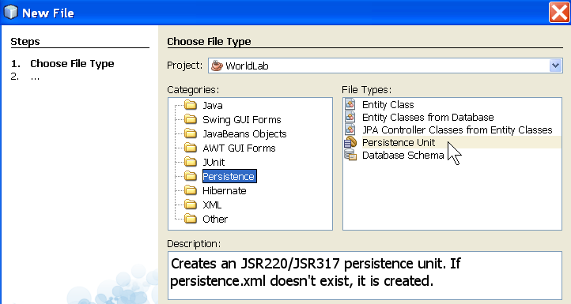
1. Create a new Java project named WorldJPA. Any name is OK, but don't use your JDBC project.
2. Create a persistence unit. Right click on the project and choose New → Other → Persistence and choose Persistence Unit.
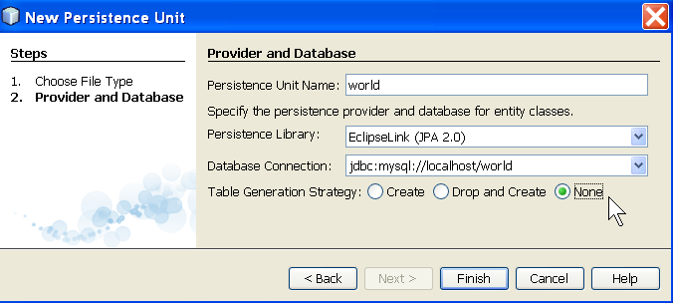
Click Next and enter a persistence unit name (usually the database name), Persistence Library (the persistence provider), and database connection. Choose "None" for table generation strategy. ("Create" means JPA will create the schema in a new database)

Netbeans creates META-INF/persistence.xml (if this file exists, it adds a new persistence unit).
3. Verify that NetBeans added the EclipseLink jars (eclipselink-2.x.jar and javax.persistence-2.0.jar) to your project in the Libraries folder. If not (or if you want to use a newer version of EclipseLink) then add them to the project by right-clicking on the project's Libraries folder.
4. Add a JDBC driver for your database. Right click on the Libraries folder and choose Add JAR or Add Library (if you have a library for the driver). NetBeans includes JDBC libraries for some databases, or you can use your own.
Check persistence.xml
The persistence.xml that NetBeans creates may contain this line:
<property name="eclipselink.ddl-generation" value="create-tables"/>
For this lab we already have a database schema, so delete this line.

Generate Entity Classes and Associations Automatically in Eclipse
Eclipse and NetBeans can generate Java classes from database table schema. They can also add JPA annotations to the classes. To do this in Eclipse, you need the Dali Java Persistence Tools extension. In Netbeans 7.0, you need the Java Persistence plugin.
We will create a Country entity with a capital attribute that refers to a City. If you have defined a database connection for World in Eclipse or NetBeans, the IDE can generate the code for you.
Eclipse
1. Connect to the database, so Eclipse JPA Tools can see the schema.
2. Right-click on project and choose New → Other... → JPA → Entities from Tables.
3. Select the connection, schema (for Derby, this is APP), and select Country table. Check "Update class list in persistence.xml". Click Next.
4. In "Table Associations", click on green "+". In the New Association dialog, choose COUNTRY and CITY tables, and JOIN using capital and id fields.
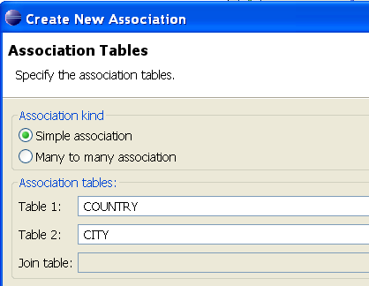 Next> 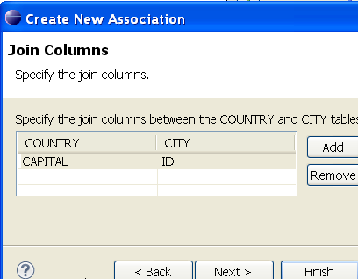 Next> 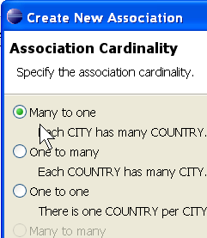

5. Click Finish. Eclipse may create the association, but in my attempts using Helios SR2 it did not.
6. Complete the dialogs to create the Country class. For "annotation type", select "field".
The mapping of capital to a City is a one-sided, many-to-one association. You may need to write this code yourself (delete the "int capital" and edit the get/setCapital methods).
package world.domain;
@Entity
public class Country implements Serializable {
@Id
private String code;

@ManyToOne
@JoinColumn(name="Capital", referencedColumnName="ID")
private City capital;
//TODO create get/set methods for Capital
public City getCapital( ) {
return capital;
}
public void setCaptial(City city) {
this.capital = city;
}

Creating Entity Classes from Schema in NetBeans
Netbeans can create an entity class from a table in the database. The generated Java code includes annotations for persisting the class.
1. Right-click on the project and choose New → Other → Persistence and "Entity Classes from Database". If you've already added a Persistence Unit, then "Entity Classes from Database" will be on the new menu.
2. Select the Database Connection and the Table to create class from:
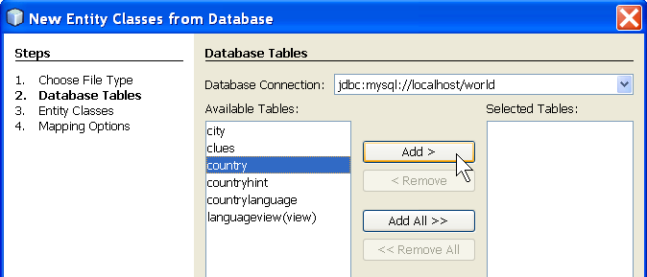
3. Click Next and enter package (world.domain) and select options. If you aren't using Named Queries or JAXB, then uncheck them.
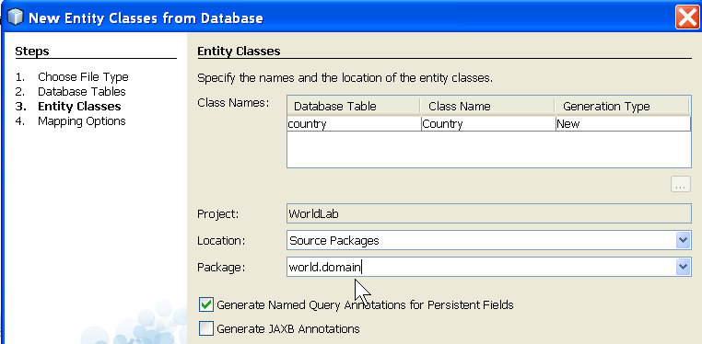
4. The next dialog lets you select how associations should be fetched and whether collections should be declared as Collection, Set, or List.

Create a Database Schema at Runtime with JPA
The first time someone runs your application how will they initialize the database tables and indices? One way is to provide an SQL file they can run (as you did it in the World database lab).
EclipseLink and other JPA provides can generate schema automatically, from the annotations in your Entity classes. To do this, add the following to persistence.xml:
<properties>
<property name="javax.persistence.jdbc.driver" value="..." />
<property name="javax.persistence.jdbc.url" value="..." />
<property name="javax.persistence.jdbc.user" value="test" />
<property name="javax.persistence.jdbc.password" value="secret" />

<!-- Create the database schema automatically -->
<property name="eclipselink.ddl-generation" value="create-tables" />
<!-- Write schema directly to database or to SQL file? -->
<property name="eclipselink.ddl-generation.output-mode"
value="database" />
</properties>
eclipselink.ddl-generation Should EclipseLink generate SQL for database initialization? Choices:
create-tables DDL to create tables only
drop-and-create-tables DDL to drop tables first, then create
eclipselink.ddl-generation.output-mode What should EclipseLink do with the DDL? Choices
sql-script Write DDL statements to a file
database Execute in database
both do both
Other useful properties are:
eclipselink.create-ddl-jdbc-file-name name of output file
eclipselink.drop-ddl-jdbc-file-name name of output file

How to Create Database at Runtime
The previous section describes how to create a database schema at runtime using JPA. It does not create the database. The database must already exist, and the user (in persistence.xml) must have privileges to create and drop tables or other DDL commands (like creating indices).
HSQLDB and Derby let you also create a new database at runtime. To do this, add some extra options to the database driver. For Derby, use:
<property name="javax.persistence.jdbc.url"
value="jdbc:derby:d:/path/mydatabase;create=true" />
For HSQLDB in embedded mode, this behavior is the default. If you connect to a non-existing database, then HSQLDB creates it. So use the usual syntax:
<property name="javax.persistence.jdbc.url"
value="jdbc:hsqldb:file:/path/mydatabase" />
For HSQLDB, when finished you should enter a "shutdown" command to integrate transaction logs (log files) into the database. Otherwise these must be processed again next time the database starts.

Reference: http://wiki.eclipse.org/EclipseLink/Examples/JPA/DDL has explanation and examples of how to configure EclipseLink in XML.

Using JPA with Existing Eclipse Projects
You can use JPA in any Eclipse Java project. It isn't necessary to create a JPA project. The benefit of a JPA project is that Eclipse can help generate annotations and synchronize persistence.xml with other parts of your application. But you can do that yourself in any project.
To use JPA in a non-JPA project, do this:
(a) add EclipseLink JAR files (better: EclipseLink library) to your project,
(b) add the JDBC driver JAR for your database,
(c) create a META-INF directory in the top-level project src directory and then create MANIFECT.MF and persistence.xml files there. Edit the files in Eclipse, using examples from this tutorial.
You can also add new JPA artifacts in non-JPA projects using New → JPA → (choose file type).
If you want to convert a Java project to a JPA project, right-click on the project (or use Project menu) and choose Configure.
In the Configure menu is a "Convert to JPA Project" item that will open the same dialog as for creating a new JPA project.
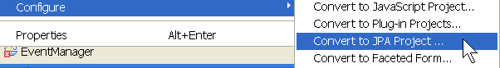

Entity Mapping using XML
In the above examples we placed persistence information inside Entity classes using annotations. This is convenient but it has a couple of negative consequences.

1. Coupling to JPA and to Database Schema
Annotations are classes provided by JPA. Putting these annotations in your domain classes couples the classes to JPA. This may limit code reuse.
A more serious form of coupling is coupling to the database schema. When we put table names, column names, or other schema details in our code, it becomes coupled to the database schema. A change in the database schema would require editing and recompiling the code.
import javax.persistence.*;
Coupling to database schema.
@Entity
Annotations create coupling to JPA.
@Table(name="COUNTRY")
public class Country {
@Id
private String code;
@ManyToOne(cascade=CascadeType.PERSIST)
@JoinColumn(name="Capital")
private City capital;
Many developers don't like this coupling and prefer a cleaner separation of application code from persistence information.

2. Persistence Details are Distributed among Many Classes
Another criticism of annotations is that they are spread through our code, even though some annotations must be consistent with each other; for example, the bidirectional relationship between a Country and its cities. Using XML, all this information can be placed in one file or at least closer together.

Define Entity Mapping using XML
To use XML for entity mapping, add one or more <mapping-file> elements to persistence.xml as shown here:
<?xml version="1.0" encoding="UTF-8"?>
<persistence version="2.0"
xmlns="http://java.sun.com/xml/ns/persistence"
xmlns:xsi="http://www.w3.org/2001/XMLSchema-instance"
xsi:schemaLocation="http://java.sun.com/xml/ns/persistence
http://java.sun.com/xml/ns/persistence/persistence_2_0.xsd">
<persistence-unit name="world" transaction-type="RESOURCE_LOCAL">
<provider>org.eclipse.persistence.jpa.PersistenceProvider</provider>
<mapping-file>META-INF/orm.xml</mapping-file>

You can use any name for the mapping files (not just orm.xml) and can put them anywhere on the project classpath. One strategy is to put everything in orm.xml in the META-INF directory as shown here; other developers prefer to put the mapping files in the same directory as the classes they map.
An example orm.xml for persisting City objects is shown here. The xsi:schemaLocation string should be on one line.
<?xml version="1.0" encoding="UTF-8"?>
<entity-mappings version="2.0"
xmlns="http://java.sun.com/xml/ns/persistence/orm"
xmlns:xsi="http://www.w3.org/2001/XMLSchema-instance"
xsi:schemaLocation="http://java.sun.com/xml/ns/persistence/orm
http://java.sun.com/xml/ns/persistence/orm_2_0.xsd">
<entity class="world.domain.City" metadata-complete="true">
<attributes>
<id name="id">
<column name="ID" nullable="false"/>
<generated-value/>
</id>
<basic name="name"/>
<basic name="district"/>
<basic name="population"/>
<basic name="timezone">
<column name="time_zone" />
</basic>
</attributes>
</entity>
</entity-mapping>
Each <entity> section specifies how to persist one entity class.
The meta-data='true" is optional; it means that this file contains all the persistence info for City, so any annotations in the City class are ignored.
<attributes> define how to map attributes of City to columns in a database table.
<id name="id"> declares the attribute id is a unique identifier for persisted objects.
<column name="ID"> says that the id attribute maps to a column named ID in the database. This isn't required: JPA can automatically map attributes to columns when the names are the same ignoring case.
<generated-value/> means that the database will generate the value of the id.
<basic name="..."/> define an attribute that can be saved as a field in the database, using standard mapping between Java types and SQL types. These are not required. Any attribute that is of type String, Date, a primitive type, or primitive wrapper class, will be automatically persisted.
<table name="CITY"/> we can specify the table name, the default is a table with the same name as the class. JPA will find a matching table name ignoring the case of letters.
Since the column names are the same as the attribute names (except for case of letters), we don't have to specify them. We can, however, specify column names if we want. For example:

Association Mapping using XML
XML mapping of the Country class illustrates how to specify database column details and how to specify associations in XML.
Add these lines to orm.xml:
<entity class="world.domain.Country">
<attributes>
<id name="code">
<column name="Code" length="3"/>
</id>
<!-- use default mapping of basic attributes -->
<many-to-one name="capital" fetch="EAGER">
<join-column name="Capital" referenced-column-name="ID"/>
</many-to-one>
</attributes>
</entity>
The <id> element specifies the column name and width for the country code. This is not required.
<many-to-one name="capital"> refers to the capital attribute of Country. The <join-column...> specifies that the column named "Capital" should be joined to the ID of the city table. This is like the SQL:
SELECT * FROM Country
JOIN City
ON Country.Capital = City.ID
For mapping of the capital field to City, we could also have specified a 1-to-1 map:
<one-to-one name="capital" fetch="EAGER">
<join-column name="Capital" referenced-column-name="ID"/>
</one-to-one>
In XML, specify a one-to-many mapping using:
<entity class="world.domain.Country">
<attributes>
...
<!-- inverse end of City-to-Country map -->
<one-to-many name="cities" mapped-by="country" fetch="EAGER">
</one-to-many>
This mapping states that elements of the cities collection are controlled by the country attribute in City. We didn't specify the class of objects that cities maps to (called the target entity). The City class is inferred from the declaration of cities (e.g., Set<City> cities). You can specify the target entity explicitly using target-entity="world.domain.City", but don't do it -- redundancy invites errors.

Summary of XML mappings
orm.xml has an optional <package> element. You can specify a default package name so you don't need to prefix the package on each class name. The package name applies to all <entity> entries until the next <package>.
<package>world.domain</package>
The mapping of a class is done in an entity tag. The attribute metadata-complete="true" means that this OR mapping specifies all mapping info, and annotations in the class should be ignored.
<entity class="world.domain.City">
</entity>
<entity class="world.domain.Country" metadata-complete="true">
</entiry>
Is the same as:
<package>world.domain</package>
<entity class=City">
</entity>
<entity class="Country" metadata-complete="true">
</entiry>

JDBC Drivers and Class Names
Database | Driver JAR file | Driver Class Name
MySQL | mysql-connector-java-5.X.Y.jar | com.mysql.jdbc.Driver
Derby embedded mode | derby.jar | org.apache.derby.jdbc.EmbeddedDriver
Derby client-server mode | derbyclient.jar | org.apache.derby.jdbc.ClientDriver
HSQLDB, any mode | hsqldb.jar | org.hsqldb.jdbcDriver
For HSQLDB and Derby the URL format is different for embedded and client-server mode.
Database | Client-server mode (URL used by client) | Embedded mode
Derby | jdbc:derby://hostname:port/path/database | jdbc:derby:D:/path/database
HSQLDB | jdbc:hsqldb:hsql://host:port/database | jdbc:hsqldb:file:/path/database

Installing Software for this Lab
1. EclipseLink. Download "EclipseLink Installer Zip" from http://www.eclipse.org/eclipselink/. Also download eclipselink-javadocs.zip. EclipseLink is an implementation of JPA 2.0.
- Unzip Eclipselink-2.x.yyy.zip to your software directory (e.g. C:/lib). This will create an eclipselink subdirectory, such as C:/lib/eclipselink.
- Move the eclipselink-javadocs.zip to this directory.
- In your IDE, create an EclipseLink library. Add two JAR files to this library:
eclipselink/jlib/eclipselink.jar
eclipselink/jlib/jpa/javax.persistence_2.0.3vXXXX.jar
- (Optional) For context sensitive help, add the eclipselink-javadocs.zip as Javadoc to both of the JARS in the library.
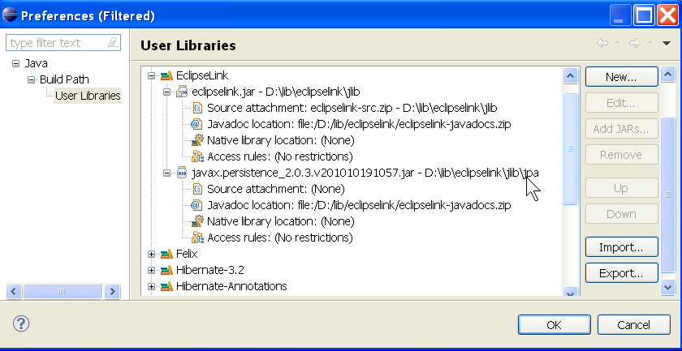

2. Derby (Optional) You can use Derby or MySQL. Derby is simple to use, but sometimes annoying since it only allows only one connection to a database. More information on using Derby is in a separate lab sheet.
- download db-derby-10.1.2.zip (or any recent version) from derby.apache.org.
- unzip to your library directory, e.g. C:/lib. The zip file will create a subdirectory named "db-derby", such as C:/lib/db-derby. The Derby drivers are JAR files in directory db-derby/lib.
- So that you can use Derby tools like ij, set the DERBY_HOME environment variable and add DERBY_HOME/bin to your shell path. In Windows, right click MyComputer, choose Properties, Advanced, and add these. On Linux, edit your .profile or .bashrc (Tcsh users, edit .login). This is Windows syntax:
set DERBY_HOME = C:/lib/db-derby
set PATH = %DERBY_HOME%\bin;%PATH%
(Optional) Create a Derby library in your IDE. There are 2 ways of using Derby: embedded server mode and client-server mode. In this lab we use embedded server mode (simpler) that is provided by the file db-derby/lib/derby.jar.

Resources
- Accessing Data through Persistence Frameworks.
http://www.developer.com/lang/article.php/3355151/Accessing-Data-Through-Persistence-Frameworks.htm
- JPA 2.0 with EclipseLink Tutorial. http://www.vogella.de/articles/JavaPersistenceAPI/article.html.
- Using the Java Persistence API in Desktop Applications, article from Sun (June 2007). http://java.sun.com/developer/technicalArticles/J2SE/Desktop/persistenceapi/. Older and biased toward Sun implementations (NetBeans, Toplink Essentials).
- MyEclipse JPA Tutorial, http://www.myeclipseide.com/documentation/quickstarts/jpa/.
Books and User Guides
OpenJPA User's Guide. This manual (in PDF form) has an ongoing example that shows every relationship you'd want to persist, and how to do it using either annotations or XML. Useful even if you don't use OpenJPA. Download from openjpa.apache.org.
EclipseLink User's Guide at http://wiki.eclipse.org/EclipseLink. User guide in Wiki form. Examples mostly use annotations. Page /EclipseLink/Examples/JPA/EclipseLink-ORM.XML has XML.
Bauer & King, Java Persistence with Hibernate, Manning, 2007. Excellent book about Hibernate and data persistence in Java, including JPA. Gavin King is founder of the Hibernate project and Bauer is member of the Hibernate development team.

Practical JPA Advice
- JPA Implementation Patterns, article at http://java.dzone.com/articles/jpa-implementation-patterns.
- Core J2EE Patterns - Data Access Object. http://java.sun.com/blueprints/corej2eepatterns/Patterns/DataAccessObject.html
- Has JPA Killed the DAO? http://www.infoq.com/news/2007/09/jpa-dao. JPA makes data access so simple, programmers wonder why bother to write DAO? This article explains why.

JPA Implementations
JPA is a specification. To use it you need an implementation. JPA implementations are:
EclipseLink, http://www.eclipse.org/eclipselink/. This is the JPA 2.0 reference implementation.
TopLink Essentials, http://glassfish.dev.java.net/downloads/persistence/JavaPersistence.html a part of the Glassfish project.
Hibernate, see JBoss Community Documentation for how to use Hibernate as JPA provider.
DataNucleus Access Platform provides both JPA and JDO. Has good documentation and support for IDEs. http://www.datanucleus.org/products/accessplatform.html
OpenJPA, an Apache project. http://openjpa.apache.org.

Resource for Other Frameworks
Apache JDO http://db.apache.org/jdo/. Implementation of JDO with good documentation. An interesting (but biased) comparison of JDO and JPA is at http://db.apache.org/jdo/jdo_v_jpa.html.
http://www.developer.com/java/ent/article.php/3325741 series of articles on Java frameworks:

